PLEASE PRINT IN BLOCK LETTERS

DISTRIBUTOR DATA
Company Name: | Marsh Micro Systems
Address: | 1084 Duncan Ave.
 | Chattanooga, TN 37404
Representative:
Telephone: | (423) 629-6245
Fax: | (423) 624-7019
E-Mail Address: | sales@marshmicrosystems.com

CUSTOMER DATA
Company Name:
Address:
Representative:
Telephone:
Fax:
E-Mail Address:

NOTE
The enclosed questionnaire is designed to assist us in selecting the system which will best meet your present and future requirements. This information will be used as a basis to quote, design and manufacture a system that satisfies your specific application. Please retain a copy for your files. Should there be any changes in requirements or specifications during the course of this project, please contact us immediately to ensure we are up to date in our understanding of your needs.

FORM COMPLETION LOG
Name of Person filling the Form: |  | Date:

MARSH MICRO SYSTEMS REPRESENTATIVE REVIEW
Regional Representative Name: |  | Date:


WRAPPED PRODUCT SPECS
Current Product Wrap Method:
Load Surface Colors:
 |  | (dark or shiny colors require special optional load height detection package)
Individual Product Package: |  | Bags ◻ Bottles □ Cartons◻  Other:
Type of Product:

LOAD STORAGE
Automated Warehouse ◻  Outside Storage ◻  Domestic ◻  Export ◻  Long Term ◻

LOAD SHIPPING
Truck ◻  Rail ◻  Boat ◻  Open Air ◻ Van ◻

LOAD SPECS
Overall  Load Dimensions | (along flow)  Length |  | (across flow)  Width | (incl. pallet)  Height | (lbs)  Weight | % of  Production
Maximum
Average
Minimum

Top Layer configuration: | Full ◻  Partial ◻  Uneven ◻   Other:
Stacking Pattern: | Column ◻ Interlocked ◻ Other:
Load Stability: | Can Be Conveyed at 30 fpm Yes ◻ No ◻  Can Be Rotated at 15 rpm Yes ◻ No ◻  Requires Top Platen Yes ◻ No ◻
Load Support: | Pallet ◻ Slip Sheet ◻     Pallet & Slip Sheet ◻  Palletless◻ Other:
Top Sheet Dispenser: | Required: Yes ◻ No ◻ Type: In Line ◻ In Cycle ◻  (dust tight) (water tight)
Rigid Top Cap applicator: | Required: Yes ◻ No ◻ (in line available only)
Slip Sheet with Tabs: | Yes ◻ No ◻ Top ◻ Bottom ◻  Length (L): _____ " Width (W): _____" Tab Length (T): _____"  Tabs to be Folded: A ◻ B ◻ C ◻ D ◻

PALLET SPECS AND PALLET TO FLOW ORIENTATION ON CONVEYORS
(Check mark types of pallets to be used)

Pallet Condition: | New ◻ | Used ◻ | Reconditioned ◻
(Check pallet flow mode regarding conveyor rollers)

Easy-Way ◻  Pallet Bottom Boards Running Perpendicular  to Conveyor Rollers |  | Hard-Way ◻  Pallet Bottom Boards Running Parallel  to Conveyor Rollers

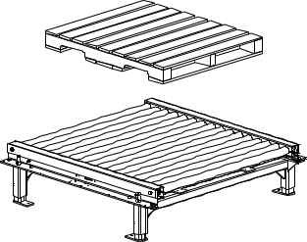
Load flow on conveyors
Load flow on conveyors
A
B
A
B
Pallet footing over conveyor rollers

 | Pallet Dimensions  (inches) | A  Flow front | B  Side | Pallet  Thickness  C | Bottom Boards  Number | Bottom Boards  Width
 | Type 1
 | Type 2
 | Type 3
Note: Easy-Way pallet orientation is highly recommended since load weight is distributed over many rollers, thus ensuring smooth load flow and efficient transfer between conveyor sections.
Hard-Way pallet orientation may require special conveyor design such as higher weight capacity, closer roller spacing, drag chain type, etc.

LOAD PROFILE

Maximum Load Overhang from Pallet Edges
Side | A | B | C | D
Inches
Seee note at bottom of page
Maximum Load Inboard from Pallet Edges
Side | A | B | C | D
Inches

Profile A Profile B Profile C
No Puncture Hazard Light Puncture Hazard Severe Puncture Hazard
◻ ◻ ◻

PRODUCTION RATE & WRAP PATTERN
 | Production Rate |  | Normal |  | Peak |  | Future
 | Loads Per Hour

Top Wraps: |  |  | Web Overwrap [over top of load]: |  | Inches

Bottom Wraps: |  |  | Web Overlap [during spiral]: |  | Inches

Circle Required Prestretch Ratio: Std 200%
Other: 50% 75% 100% 125% 150% 175% 225% 250% 275% 300%

Carriage size? | 20” ◻  | 30” ◻  | Film Gauge?

 | (Wulftec's powered pre-stretch carriage standard film range capacity is 60 gauge to 1.5 mils)

WRAP SPECS
 | (Check mark required items)
 | Item | ✓ | Description
 | Std Wrap: 2" up form top of rollers |  | (Wrap load & part of pallet)
 | Non Std Wrap: wrap load & not pallet |  | Indicate height from top of rollers:
 | Non Std Wrap: wrap entire load & pallet |  | (Requires pop-up option)
 | Banding Wrap
 | On Way Wrap
 | Other Wrap Pattern |  | Describe:
 | Note: Large inboard or overhang conditions may impair wrap ability to secure load to pallet.

TYPE OF SYSTEM

TURNTABLE SYSTEM LOADING AND FLOW SPECS
CIRCLE REQUIRED LOADING UNLOADING POINTS (ARROWS)

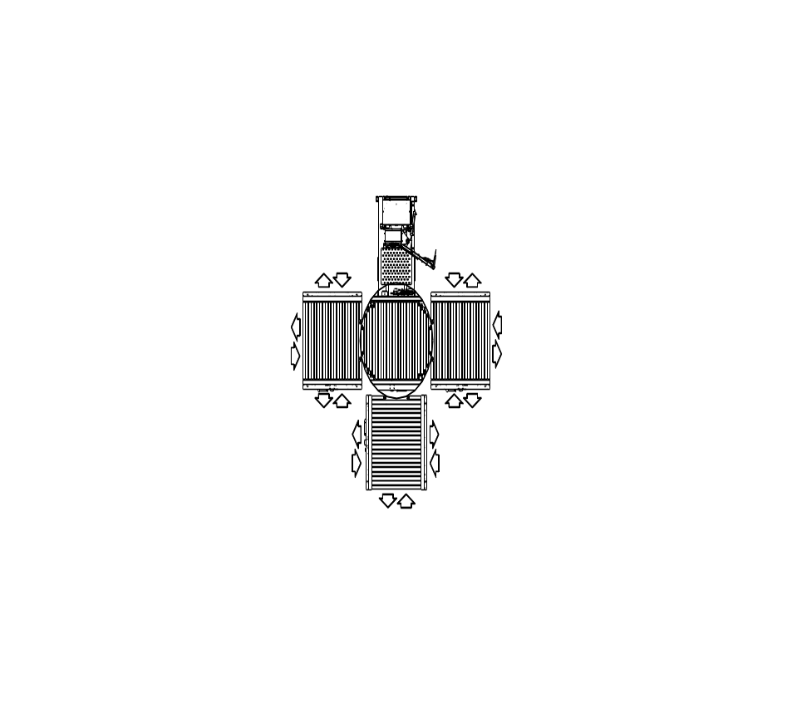

Other ◻  (Attach sketch)

(Check mark required items)
Standard | ✓ |  | ✓ | Required Non-Standard (Describe)
In Tower |  | Controls |  | In NEMA Enclosure
Beside Tower  Controls Facing Infeed Conveyor |  | Enclosure Location |  | Show position & distances on sketch
Straight Through |  | Flow |  | 90º Index on Infeed
 |  |  |  | 90º Index on Outfeed

ROTARY ARM SYSTEM LOADING AND FLOW SPECIFICATIONS
CIRCLE REQUIRED LOADING UNLOADING POINTS (ARROWS)

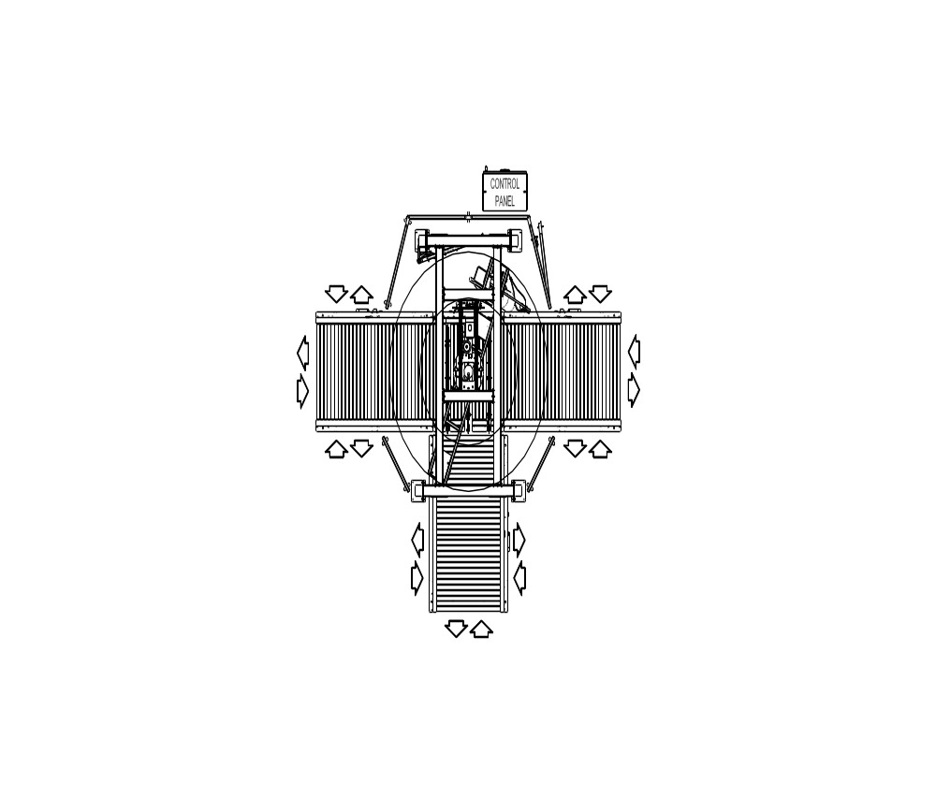

Other ◻  (See attached sketch)

(Check mark required items)
Standard | ✓ |  | ✓ | Required Non-Standard (Describe)
As Shown on Above Sketch |  | Enclosure Location |  | Show position & distances on sketch
By Wulftec |  | Process Conveyor |  | By Others
Straight Through |  | Flow |  | 90º Index on Infeed
 |  |  |  | 90º Index on Outfeed

CONVEYOR SYSTEM CONFIGURATION
Note: All required conveyors must be listed.

Required Conveyor Sections | Number | Length (Feet)

Powered Infeed Sections
Powered Process Section (rotary arm system) |  | ---
Powered Process Turntable |  | ---

Powered Outfeed Sections

Gravity Outfeed Sections

CONVEYOR SYSTEM SPECIFICATIONS
(check mark required items)

Standard | ✓ |  | ✓ | Required Non-Standard (Describe)
Rollers |  | Conveyor Type |  | Chain Conveyors ◻  Other:
30 fpm |  | Speed
18" |  | Pass Height  (top of rollers or top of chains)
52" |  | BFR
2½"Ø |  | Rollers Diameter
3" c/c  3.75” c/c (wca-150) |  | Rollers Center to Center
17" c/c |  | Chains Center to Center
Single Fwd Jog * |  | Manual Function |  | Independent Fwd/Rev per each Section

*Note:
WCRT-200: process conveyor comes standard with manual Fwd/Rev function.
WCA-200: turntable process conveyor, 1 infeed and 1 outfeed conveyor, each come standard with manual Fwd/Rev function.

LOADING / UNLOADING
(Check mark required items)

Infeed to Wulftec System | ✓ |  | Outfeed from Wulftec System | ✓
From Palletizer Conveyor |  |  | To Other Powered Conveyor
By Fork Lift |  |  | To Other Gravity Conveyor
By Dual Fork Lift |  |  | By Fork Lift
By Clamp Truck |  |  | By Dual Fork Lift
By Push/Pull |  |  | By Clamp Truck
By Powered Hand Jack * |  |  | By Push/Pull
By Manual Hand Jack * |  |  | By Powered Hand Jack *
By Overhead Monorail |  |  | By Manual Hand Jack *
 |  |  | By Overhead Monorail
* Note: If you have checked any "Hand Jack", please specify fork sizes and spacing (between forks) hereafter:

COMMUNICATIONS
(Check mark required items)
with Wulftec Infeed Station | ✓ |  | with Wulftec Outfeed Station | ✓
Dry Contact Signal (std) |  |  | Dry Contact Signal (std)
Time Delay Photoeye |  |  | Time Delay Photoeye
Safety Fork Lift Photoeye |  |  | Safety Fork Lift Photoeye
Pull Cord Station |  |  | Pull Cord Station
Lanyard Push Button Station |  |  | Lanyard Push Button Station
Pedestal Push Button Station |  |  | Pedestal Push Button Station

SYSTEM COMPONENTS SPECIFICATIONS
(Check mark required items)
Standard | ✓ | Component | ✓ | Required Non-Standard  (Describe)
Allen Bradley SLC 5/03 (wcrt-200 / wca-200)  Micrologix 1200 (wcrt-175 / wca-150) |  | PLC
Allen Bradley Power Flex 4 – 230 V |  | Drives
Balder 208-230/460VAC/3Ph/60Hz |  | Motors
Sick |  | Phoyoeyes
Allen Bradley |  | Limit Switches
Allen Bradley Panel View 600 |  | Screen & Switches
SMC |  | Pneumatics
English |  | Control Panel Language
20" |  | Film Size |  | Optional 30"
Standard |  | Film Type |  | One Side Cling

PAINT SPECS
(Check mark required items)
Item | ✓ | Notes
Wulftec Std Gray
Special Color |  | Customer to Supply Paint Chips or Paint Specs
Epoxy Paint *
Steel It Paint *
Other Non Std Paint |  | Make, Type, Color
Enclosure color |  | Standard gray ◻  Other:

*Note:
Epoxy paint is mainly used in wash down applications and food processing plants.
Steel It paint is weather, abrasion and corrosion resistant. It is used in applications such as ultraviolet rays, chemicals, oils, alkalis, food acid, water immersion, abrasion, and high-pressure wash-downs. Available in gray color only. USDA Approved.

FIELD SITE CONDITIONS

Ceiling Clearance Height: |  | Inches

Temperature | Maximum: |  | º F | Typical: |  | º F | Minimum: |  | º F

Full Height Wash Down Area ◻ Up to Conveyor Top Line Wash Down Area ◻ Very Dusty ◻
Potential Corrosives ◻ Other Conditions:

POWER SUPPLY SPECS
(Check mark required items)
Standard | ✓ |  |  | ✓ | Non-Standard (Describe)
Wulftec Std  230VAC / 3Ph / 60Hz |  | Available  Power Supply |  |  | VAC: Ph: Hz:
Consistent |  | Power Source condition |  |  | Subject to Spikes / Drops / Surges
Not Required |  | Surge Protection |  |  | Required Lightning Arrestor Only *
 |  |  |  |  | Required Full Power Regulator *

* Note: Lightning arrestor includes only surge coil. Full power regulator includes filters, peak clipper, and regulator circuits.

COMPRESSED AIR SUPPLY SPECS
(Check mark required items)
Standard |  |  | ✓ |  |  |  | ✓ | Non-Standard (Describe)
Wulftec Std  3 CFM / 80 PSI Clean Dry Air |  |  |  | Available  Compressed Air Supply |  |  |  | PSI: CFM:  Clean Dry Air
Not Required |  |  |  | Air Compressor Unit |  |  |  | No compressed air available on site
Not Required |  |  |  | Air Dryer Unit |  |  |  | No clean dry air supply on site

SYSTEM INSTALLATION & START UP
Installation? | by Wulftec | ◻ | by Distributor |  | ◻ | by Outside Contractor |  |  | ◻ | by Plant Personnel | ◻
*Start-up? | by Wulftec | ◻ | by Distributor |  | ◻ | by Outside Contractor |  |  | ◻ | by Plant Personnel | ◻
*Note: Start-up must be done or supervised by a certified Wulftec technician.

DOCUMENTATION
(Indicate total number of items required) | for CUSTOMER |  |  | for DISTRIBUTOR
User Manual (Std = 1 for Customer + 1 for Distributor)
Program Disk (Std = 1 for Customer + 1 for Distributor)
Electrical Schematics(Std = 1 for Customer + 1 for Distributor)
Program Print Out (Non Std)

